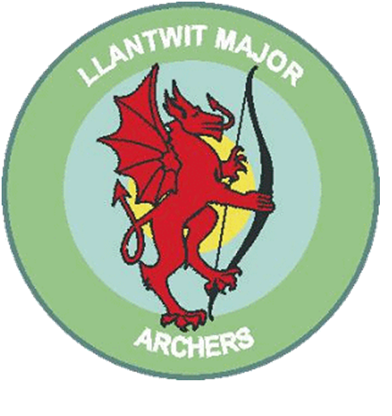
Llantwit Major Archery club

Junior Polo Shirt from £15.00 each
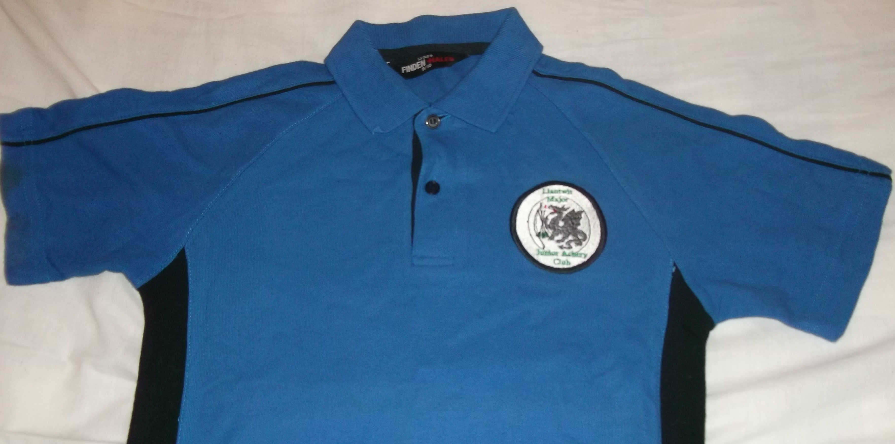
A quality Polo Shirt with Llantwit Major Junior Archers Logo on left chest panel, complete with Llantwit Major Archers vinyl printed on the reverse. Your name (first name or full name) can be added on the back underneath the Llantwit Major Archers at NO EXTRA COST, this is optional.
If you require your name embroidered underneath the club badge on the front of the shirt this will cost an additional £1.50.
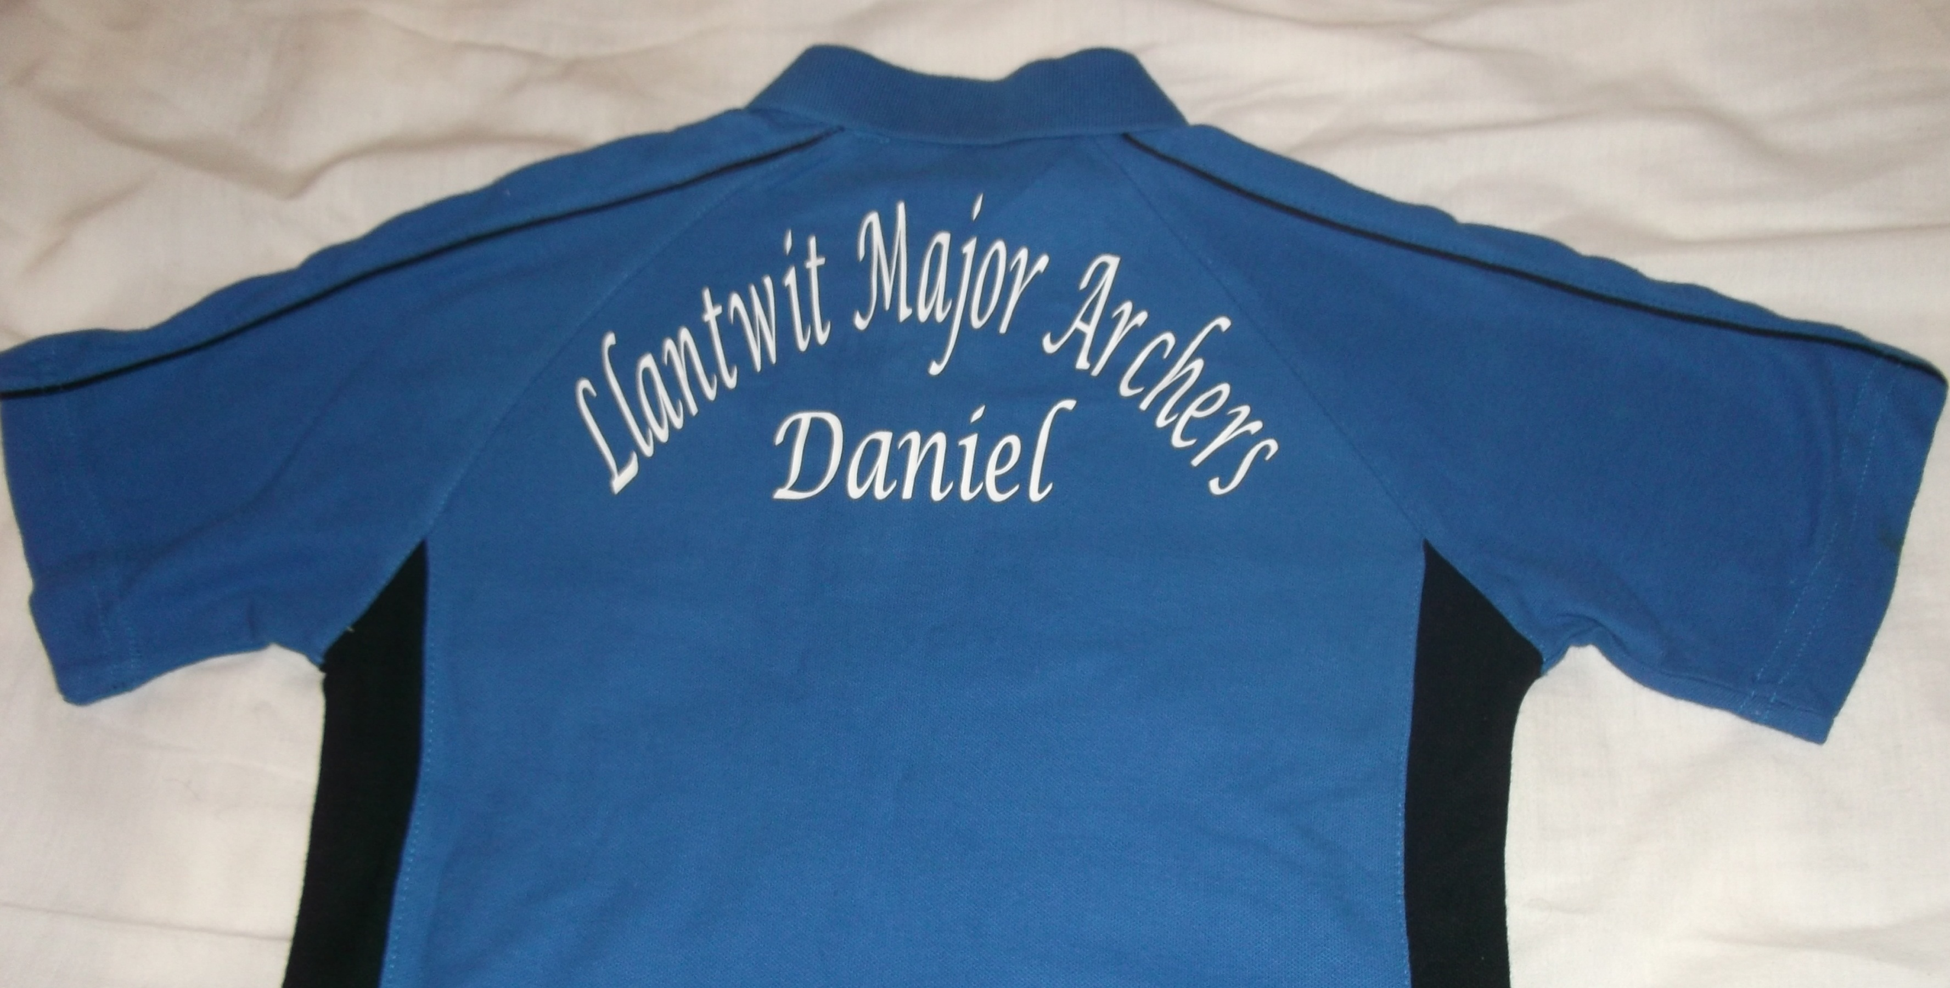

PLEASE ENSURE YOUR WRITING IS LEGIBLE!
ORDER NAME
Size | Qty | Name on Back FREE LEAVE BLANK IF NOT REQUIRED | Name of Front £1.50 PER SHIRT LEAVE BLANK IF NOT REQUIRED | Cost
Age 5/6 24”
Age 7/8 26”
Age 9/10 28”
Age 11/12 30”
Age 13/14 32”
 |  |  | Total

Please make cheques payable to Llantwit Major Archery Club

